

Game Overview: F1 Grand Prix™
On the Go with F1 Grand Prix™ on PlayStation®Portable™

F1 Grand Prix™ is the first official licensed game of the FORMULA ONE™ World Championship for the PlayStation®Portable from Sony Computer Entertainment Europe.

PSP™ is a revolution in entertainment with music, film and gaming delivered on the go. Every PSP game is fine-tuned to ensure games are quickly accessible and can be enjoyed bite-sized for short journeys - or in full for the long-haul flight.

The Real Deal
All the official cars, drivers, teams and tracks including the new Istanbul track, Turkey.

Gaming at your ‘Finger Tips’
Accessible game-play with various scenario options so you can race in a Grand Prix at the touch of a button, options are:

- Quick Race Mode: A ‘mini’ Grand Prix of three quick race laps
- Challenge Mode: Various challenges from Speed Tests to Racing Line Tests
- Eliminator Championship Mode: A race where a car is ‘removed’ after each lap
- World Championship
- Head to head: One on one racing

Downloadable Content
Keep your game up-to-the minute with a range of downloads:
- Grid Updates: get the weekend’s race grid line-up after the qualifying session
- Driver Updates: get any driver changes during the season
- Car Updates: keep get you cars ‘fresh’ with latest livery downloads

Wireless
- Link up to other PSPs via Wireless for multi player races, Ghost Car and Best Time Exchange mode
- From two to eight players

More/…

Interactive Pit Stops
By hitting the correct button sequence as directed on screen, pit times can be improved manually during the game play.

ENDS

Notes to Editors

For more information contact your local PR Manager.

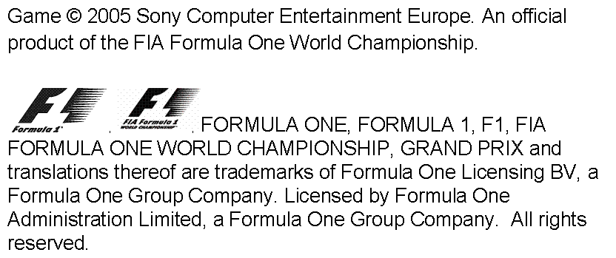

About PlayStation Portable™
PlayStation Portable is a new handheld entertainment system that allows users to enjoy 3D games, with high-quality full-motion video, and high-fidelity stereo audio. With graphics rendering capability comparable to that of PlayStation®2, PlayStation Portable features a 4.3 inch widescreen, high-resolution TFT display. PlayStation Portable also adopts a newly developed compact but high-capacity (1.8GB) optical disc, Universal Media Disc (UMD), as its storage medium. With a wide range of accessories and connectivity options, including Memory Stick Duo™, USB 2.0, IR port and Wireless LAN.

About Sony Computer Entertainment Europe Ltd.
Sony Computer Entertainment Europe (SCEE), based in London, is responsible for the distribution, marketing and sales of PS one®, PlayStation®2 and PlayStation Portable® software and hardware in 102 territories across Europe, the Middle East, Africa and Oceania. SCEE also develops, publishes, markets and distributes games software for the three formats, and manages the third party licensing programs for these platforms in the PAL territories. At the end of March 2005, over 40 million PlayStation® units had been shipped across these PAL territories, over 102 million worldwide. Between its European debut on 24 November 2000 and the end of March 2005, over 31 million PlayStation®2 units have been shipped across the PAL territories, over 87 million world-wide, making it one of the most successful consumer electronic products in history.

PlayStation and the PlayStation logo, PS one and PS2 are registered trademarks of Sony Computer Entertainment Inc. All other trademarks are property of their respective owners.

More information about PlayStation products can be found at http://www.scee.com and www.playstation.com.

